1. Order Management Setup

•Define Order Management System Parameters

Setting up Transaction Types: Setup > Transaction Types> Define

Standard Line Order Transaction

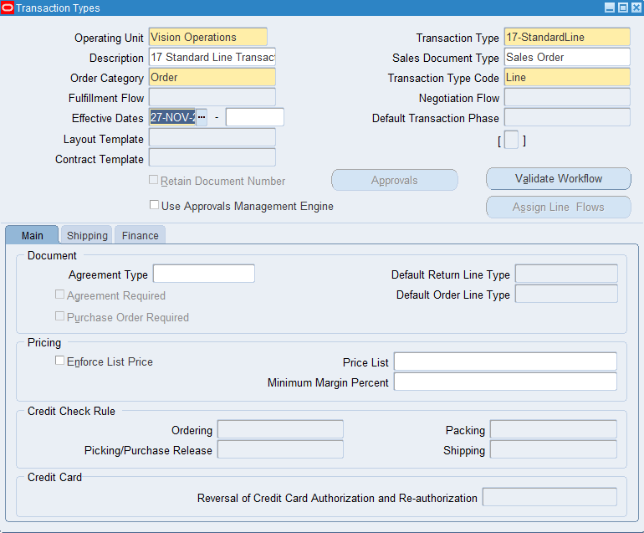

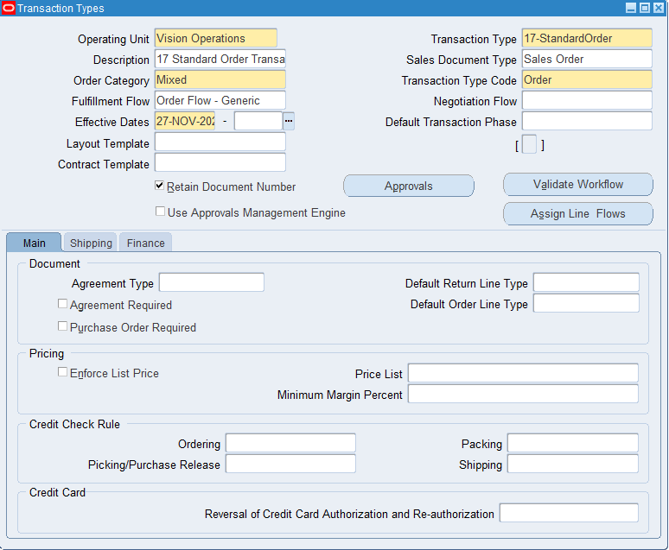

*Standard Order Transaction*

**Creating a Document Sequence and Assigning It to the Transaction Type**

Setup>Documents>Define

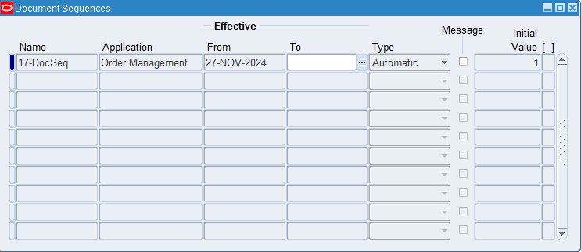

Setup>Documents>Assign

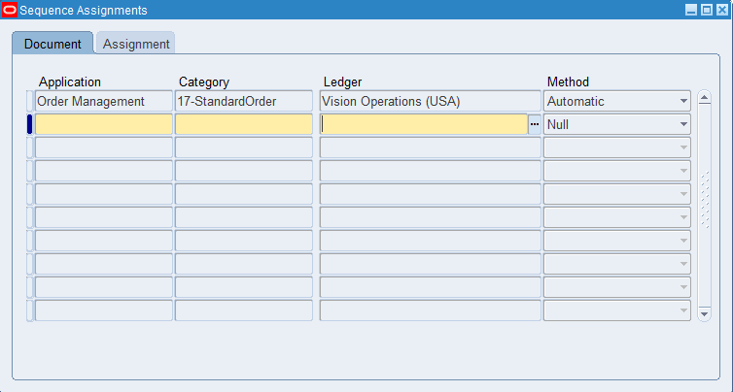

**Create a Sales Order**

2. Customer Management [Customer Creation]

•Define and Maintain Customer Accounts and Contacts

**Create a Customer**

Customers>Standard

•Setup Customer Shipping and Billing Information

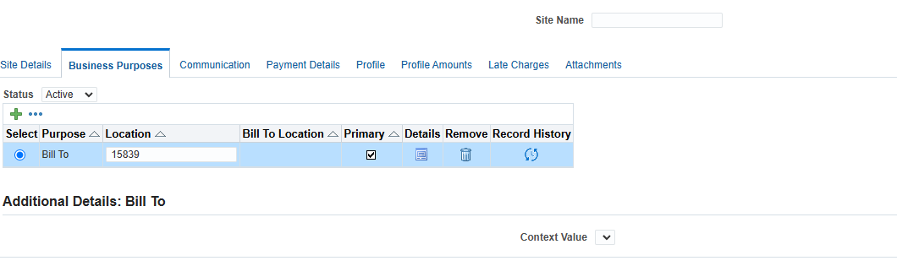

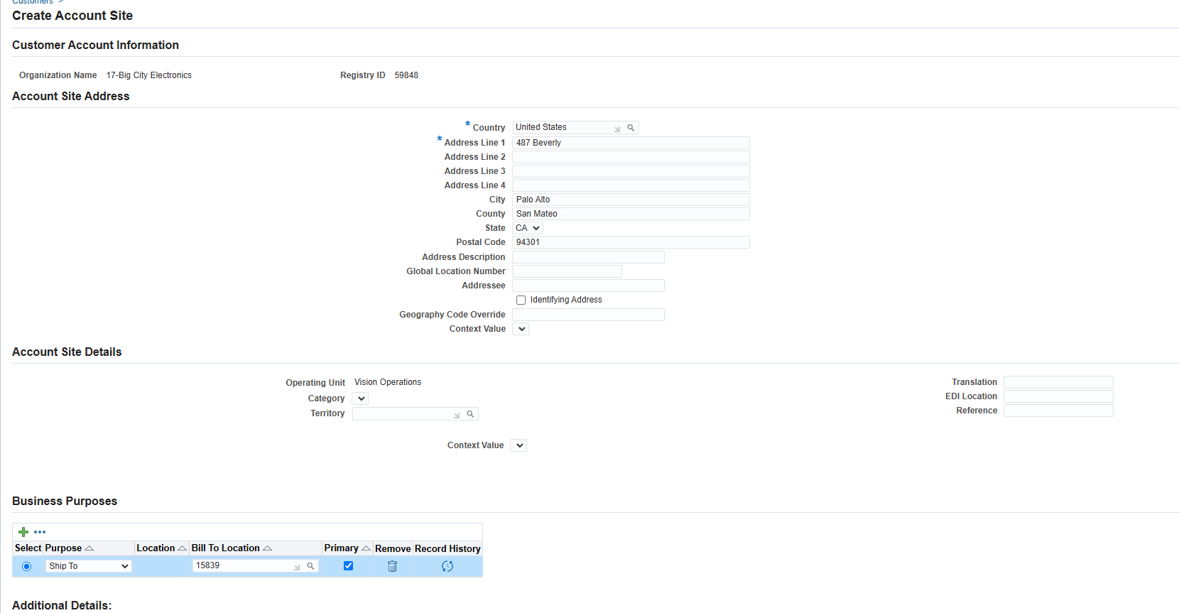

•Manage Customer-Specific Pricing and Discounts

**Create a new Price List**

Purchasing>Advanced Pricing> Price Lists > Price List Setup

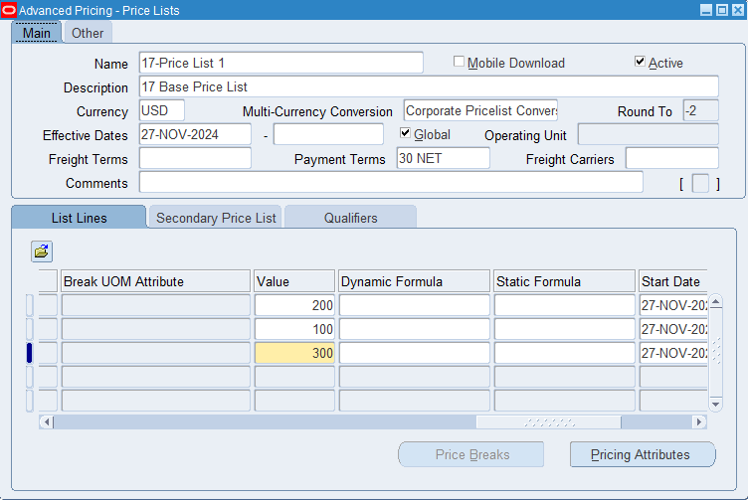

**Creating a Discount Modifier**

Purchasing> Advanced Pricing > Modifiers > Modifier Setup

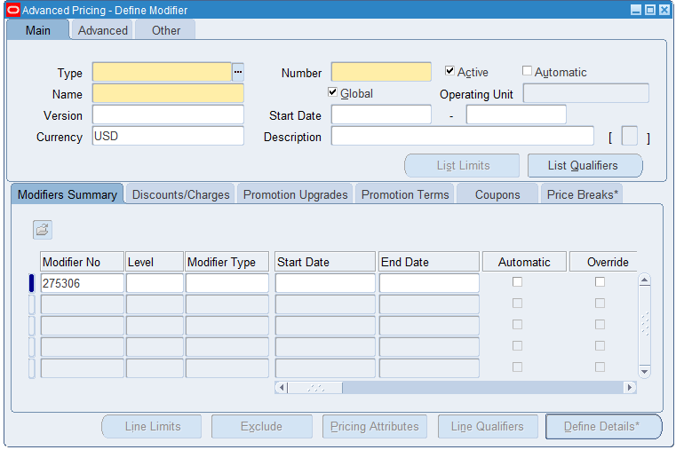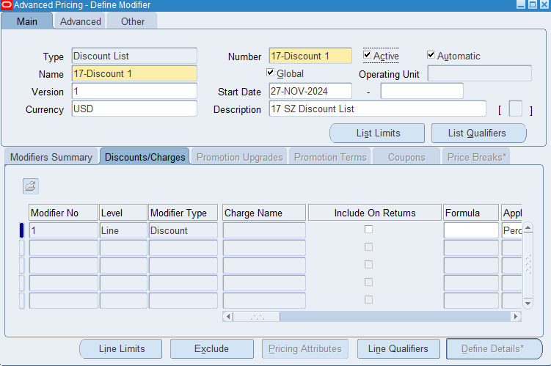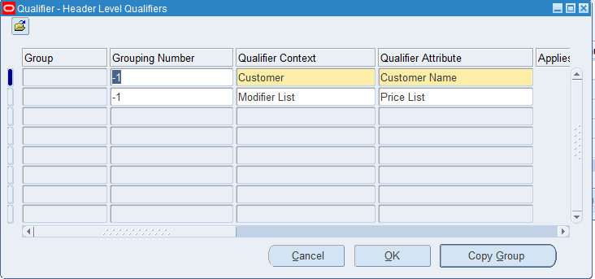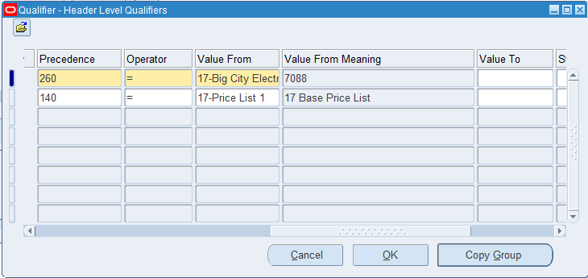

3. Sales Order Creation and Entry

•Create Sales Orders Manually or Import from External Systems

**Creating a Sales Order Using a Discount Modifier**

Orders, Returns > Sales Orders

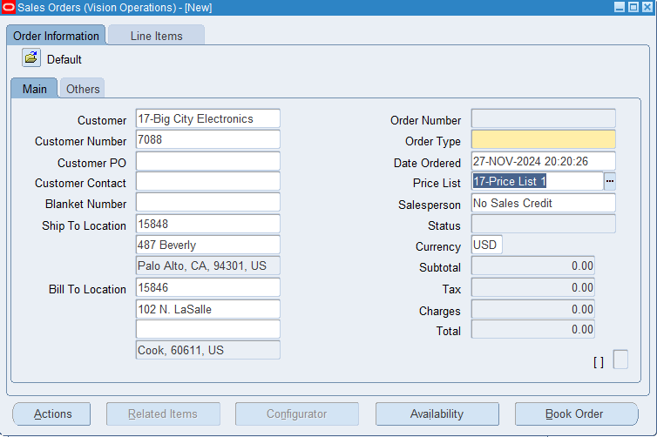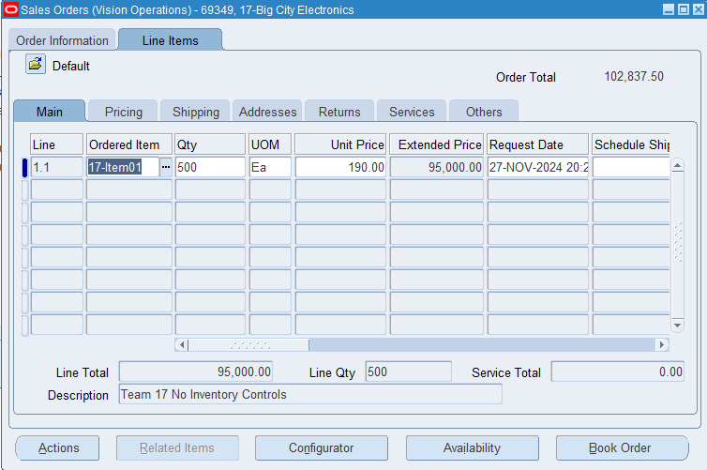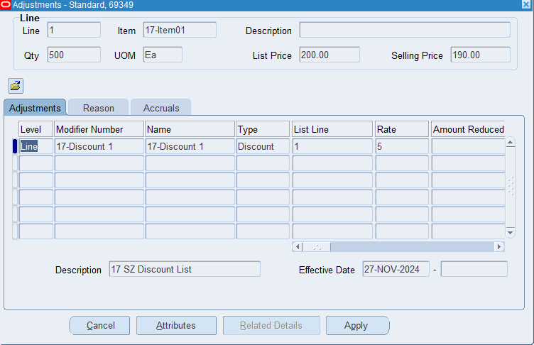

4. Invoicing and Accounts Receivable Integration

•Generate Invoices upon Shipment or Fulfillment

**Create An Order**

Orders, Returns > Sales Orders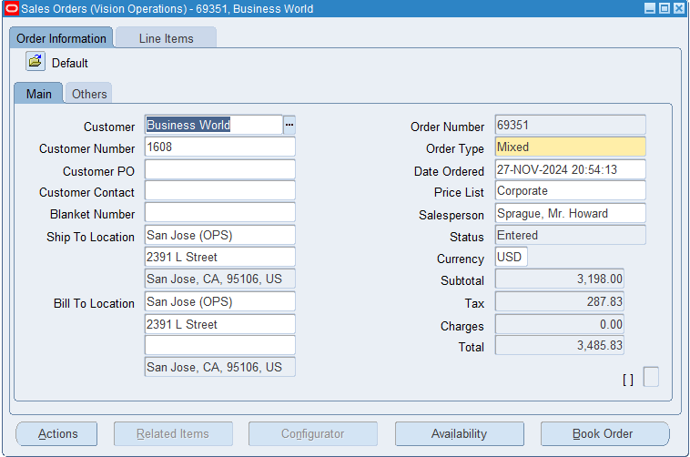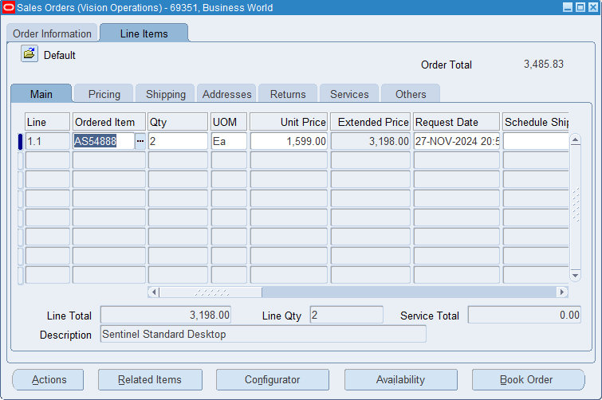

**Save and Book the Order**

Tools> Workflow Status> View Diagram

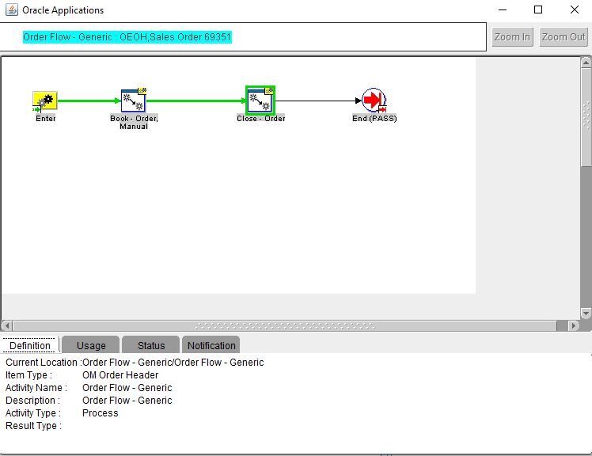

**Pick release the order**

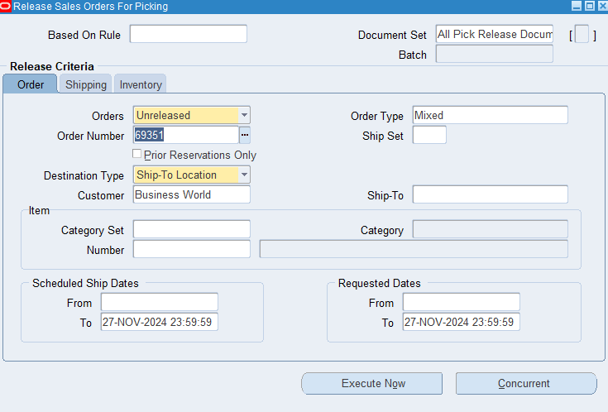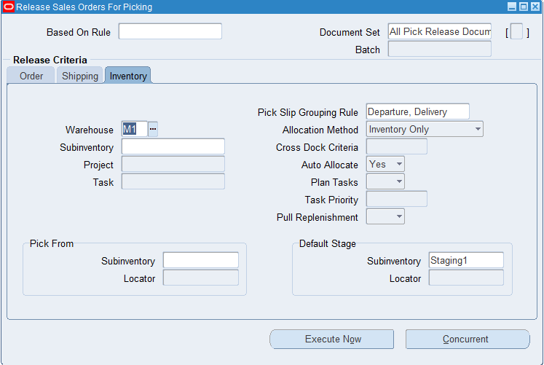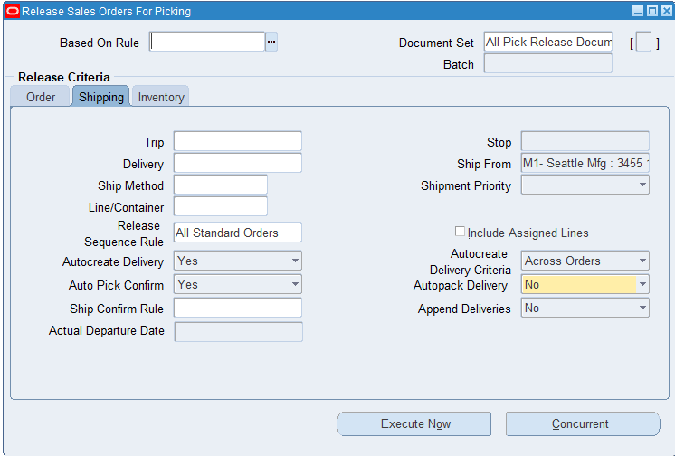

Execute Now

**Ship confirm the order**

Shipping> Transactions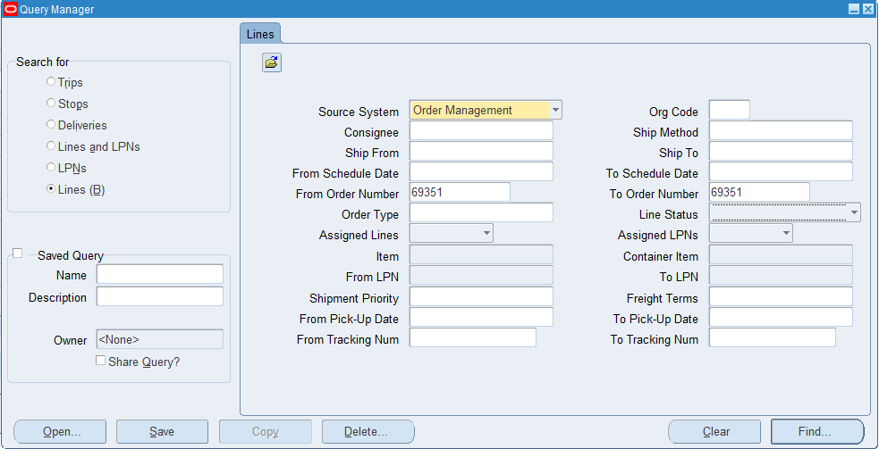

**Use AutoInvoice to create an invoice for the order**